Common training framework - HP education in Europe
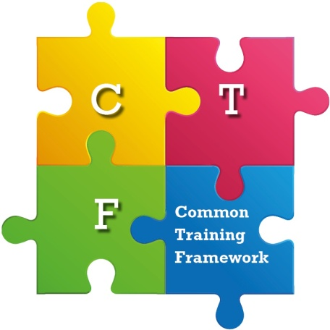The European Association of Hospital Pharmacists (EAHP), and its 35 member country platforms are creating a common training framework for hospital pharmacy education in Europe.
The framework will support the raising of standards in hospital pharmacy practice and thereby enhance the quality of, safety of, and equity of access to, patient care in every European country.
It will provide a key tool for all countries in delivering the vision of the 44 European Statements of Hospital Pharmacy.
To learn more about this project click HERE.
-----------------------------------
CTF CONSULTATION!
The “draft common training framework” for hospital pharmacy developed by the working group was submitted to a public consultation (in a Delphi approach) from March to April 2017. The working group is currently reviewing the results of the consultation.
Last update: 14 August 2017

HP Practice
- What hospital pharmacists do
- FIP global statements
- National legislation on hospital pharmacy
- Good Practice Initiatives
- Common training framework
- European Statements of Hospital Pharmacy
  - SILCC
  - Self-assessment tool

What is a common training framework?
The Common Training Framework (CTF) is a legal tool to achieve automatic professional qualification recognition across EU countries, meaning that learning outcomes and competencies received in one European country are recognized throughout Europe.
A common training framework for hospital pharmacy will represent an important international agreement on the competencies, knowledge, skills and attitudes required by the profession to deliver on the 44 European Statements of Hospital Pharmacy. Thereafter, it is intended that the common training framework will be initially used as a flexible tool for hospital pharmacy development across Europe, fully reflecting national and regional realities. This includes being:
- an inspiration for the development of competency-based education and training programmes for hospital pharmacy, especially in those countries where formal structures of this kind may be under consideration.
- an opportunity for cross-border cooperation in the provision of hospital pharmacy education and training.
- a European benchmark to which existing national programmes of hospital pharmacy education and training can be compared.
- a reference tool for those with responsibility for the provision of workplace based systems of training and development.
In the longer term, it is hoped that ongoing and enhanced agreement between countries on the competencies required for practice of hospital pharmacy may present new opportunities for labour mobility.
Learn more about the benefits of implementating CTF

Why a common training framework in hospital pharmacy?
The 44 European Statements of Hospital Pharmacy, agreed via EAHP’s national member country platforms, and in partnership with European patient and healthcare professional organisations, set out the vision of what hospital pharmacy should aspire to achieve in all countries.
What is now required are the tools for the profession to achieve this vision, and uppermost among these is the educational background to fulfill tasks that go above and beyond that provided for in the initial MPharm qualification. These include such areas as medicines production and compounding, interface management, rare diseases, advanced therapies and the conduct of clinical trials.
By agreeing at a pan-European level the framework of competencies required to achieve the European Statements of Hospital Pharmacy, all countries can have clarity, and a benchmark, as to what education is necessary to underpin the highest performance of their hospital pharmacy profession. In short, the path to improvement is further illuminated.
An eventual common training framework of legal standing will achieve a step towards change in hospital pharmacist labour mobility and open new doors to the sharing of best practices, knowledge and improvement opportunities.
The ultimate guiding mission of all involved in the common training framework project is to enhance the quality of, safety of, and equity of access to, patient care in every European country. The hospital pharmacist’s role in achieving this mission cannot be realised without fundamental educational underpinning to advanced practice.

Who develops the project?
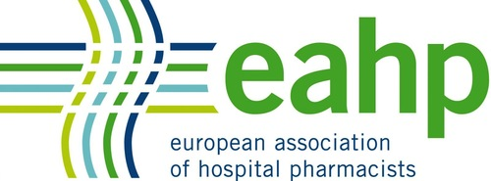
The common training framework is an initiative led by the European Association of Hospital Pharmacists and conducted from amongst its membership, the 35 country platforms representing hospital pharmacists at the national level.
Further information about the governance structure of the project is available here.

The European Association of Hospital Pharmacists (EAHP), and its 35 member country platforms are creating a Common Training Framework for hospital pharmacy education in Europe.
The overriding motivation for creating the common training framework (CTF) for hospital pharmacy specialisation is “to enhance the quality of, safety of, and equity of access to, patient care in every European country”. Underlining this motivation are five key benefits that highlight why a CTF is so important for EAHP and its members. These include the patient benefit, improving labour mobility and the benefits that arise from that, a benchmark for all European countries to strive for, a vital strategic tool for realizing the European Statements of Hospital Pharmacy and the culmination of decades of EAHP and member advocacy.
The CTF framework will therefore support the raising of standards in hospital pharmacy practice and thereby enhance the quality of, safety of, and equity of access to, patient care in every European country.
The Common Training Framework in Hospital Pharmacy Project is being led by
European Association of Hospital Pharmacists

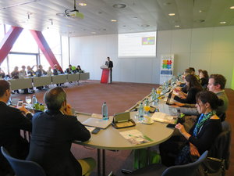

EAHP presents the progress made in implementing the Common Training Framework for hospital pharmacy to national competent authorities
Read More →
Apr 15, 2019

Labour Mobility Report shows support for the creation of a CTF
On 31st January 2018, the European Association of Hospital Pharmacists (EAHP) released its Labour Mobility Report during an event hosted on its premises. Representatives of the European Commission, fellow pharmacy organisations and other associations working on the realisation of a Common Training Framework (CTF) had the opportunity to learn more about the views of hospital pharmacists on labour mobility and EAHP's CTF project.
Read More →
Jan 31, 2018

CTF Working Group 2 - Literature review published
The Common Training Framework (CTF) project of the European Association of Hospital Pharmacists (EAHP) has a new milestone to report. Working Group 2 which was tasked with the compilation of supporting evidence published a literature review.
Read More →
Oct 27, 2017

Registration for the CTF consultation opened – deadline extended to 20 February
The European Association of Hospital Pharmacists (EAHP) is inviting all interested organisations and individuals to register to participate in an online consultation on a common training framework (CTF) for hospital pharmacy.
Read More →
Feb 6, 2017

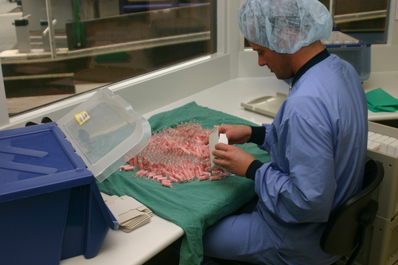

ABOUT
Find out about more about the CTF project.
Learn More →

